Integrating Azure resource Logs with Splunk
The document provides details on how to integrate Azure Resource logs with Splunk. This integration requires multiple steps such as follows:
- Create a Service principle for the WUIT.
- Create Event hub namespace & Event hub.
- Grant the necessary Event Hub permissions on the Service principle.
- Enable logging on each of the resources that you want to collect logs on.
- Ship the resource logs Event hub.
- Provide the necessary Event hub credentials to WUIT for Splunk integration.

Step 1: Create a Service Principle
- Open a ServiceNow request with WUIT to create a Service principal.  - Follow the link: WUSTL CSP Portal - WUSTL Portal (service-now.com)  - Once in ServiceNow, search for Service account, select “New Service Account” | 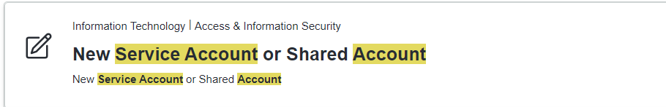
- After selecting the “New Service Account” option  - For “Request Account Type” select “Service Account” and fill out the form as needed.  - After filling out the form, before you checkout, ensure to enter “CC0002751” as your cost center number.  - P.S! In the ticket, please request that they email you the SecretID, TennantID & ClientID of the Service Principle. | 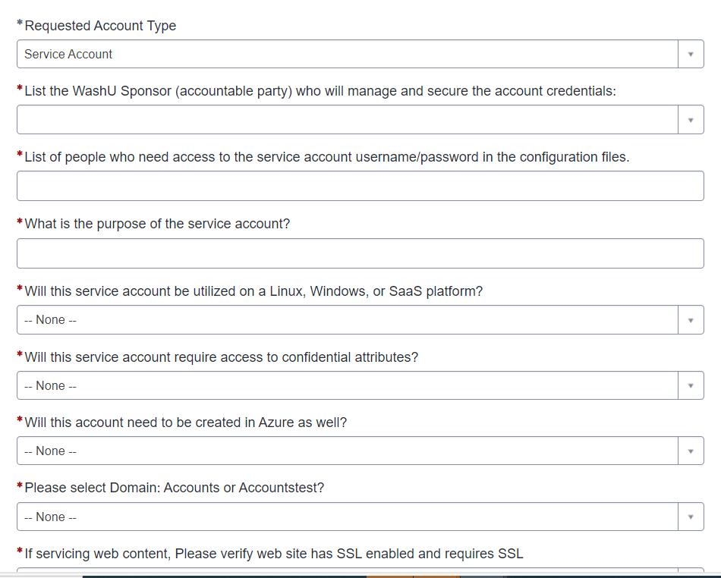

Step 2: Create Event Hub Namespace n azure
- Log into azure and go to the Event hub Service and create an Event Hub Namespace. | 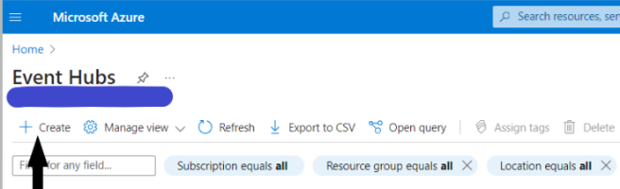
- In the namespace creation window, ensure you select the subscription in which your resources are hosted in.  - As namespaces are restricted to resources within the same subscription.  - After selecting the subscription, fill in the other options as needed.  - In the advanced window, always select the latest version i.e., Version 1.2. | 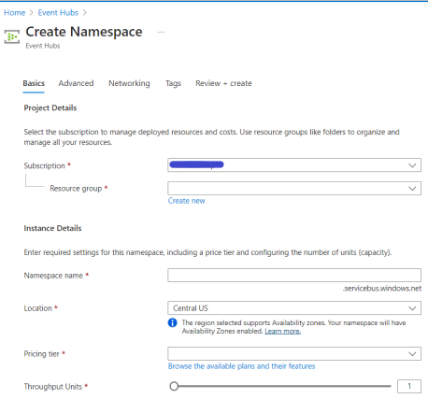
- In the networking window, you can make it publicly or privately accessible. If you select private access, you will have to create a private endpoint. | 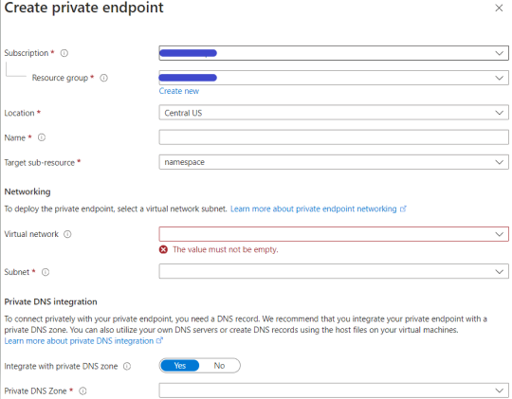
- After the namespace is created, go to Entities -> Event Hubs.  - Select the +Event Hub to create an Event hub.  - The log will be shipped to the created event hub. | 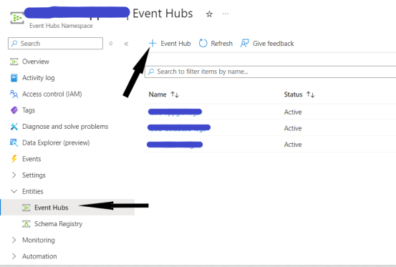

Step 3: Grant Service Principal Permissions.
- Go to the created Event hub Namespace, then go to Access Control (IAM)  - In the add Role Assignment Window, select the “Azure Event Hubs Data Receiver” role and select the appropriate service principle. | 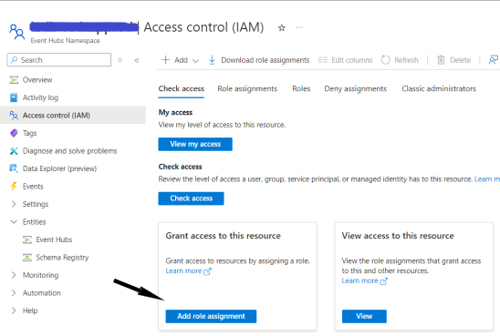

Step 4: Enable logging of Resources & ship logs to Event hub:
- In azure, go to the resource, open the Monitoring Window, select Diagnostic Settings and select add Diagnostic Settings | 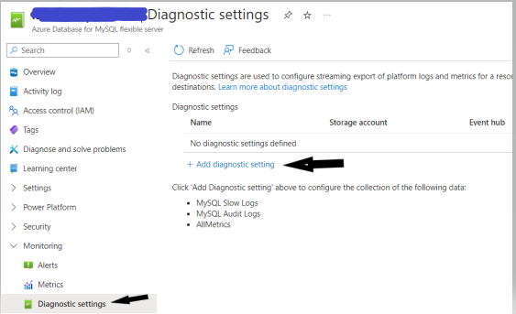
- In the Diagnostic Setting window, select Stream to an event hub.  - Next, enter the needed values for the subscription, Event hub namespace, event hub.  - Next select the appropriate logs you would like to send. | 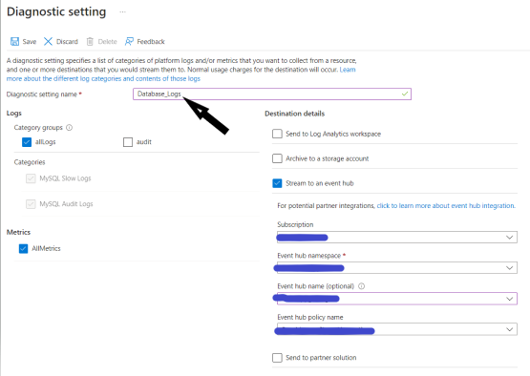

Step 5: Ship logs to Splunk
- Once you successfully ship logs to the appropriate Event hub, you will need to open a ServiceNow Data Onboarding request with WUIT.  - Click on the following link to create a request: Splunk Data Onboarding Request - WUSTL Portal (service-now.com) | 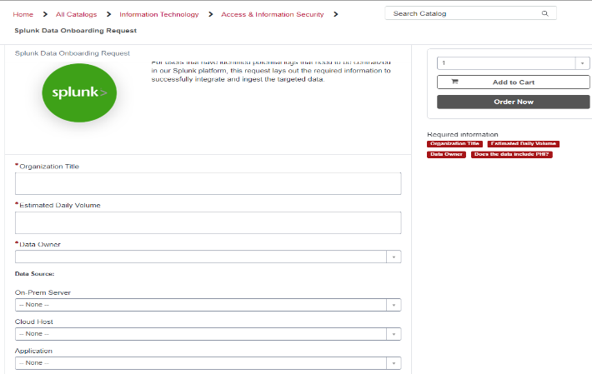
- Once the request has been created you will need to provide the following details to the WUIT Splunk team | 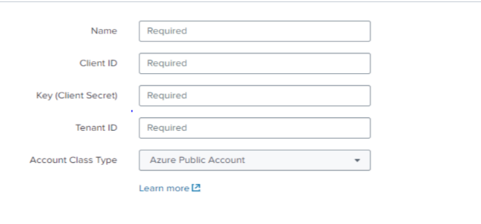  The provided info would look like this:  Event Hub Namespace: i2db-test000.servicebus.windows.net  Client ID: 50test00-test6-4188-944c-  SecretID:8GFRST~b9Rftx2CPlt5qu1L1DCFDqZz4J  TenantID: 4ccca3b5-71cd-4e6d-974b-4875581967

