REDCap Database Upgrade
This document provides a step-by-step process on how to upgrade the REDcap MySQL application database whenever the redcap application version is upgraded. To perform a database upgrade, please use the following steps:
- The first step is to log into the Redcap application. | 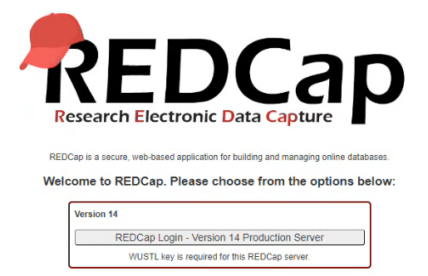
- After, login into the redcap application, click on the control center. | 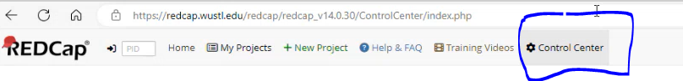
- Next, to take the application offline, go to System Configuration -> General Configuration: | 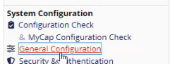
- In General Configuration, you will need to take the system offline. | 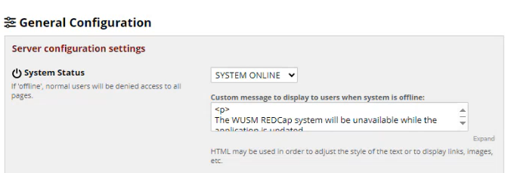
- Go to Azure Devops for the query and download it.  - The script is comprised of DDL & DML. | - Task 47374: PROD: REDCap PROD upgrade to REDCap v14.0.34: DB Changes - Boards (azure.com)  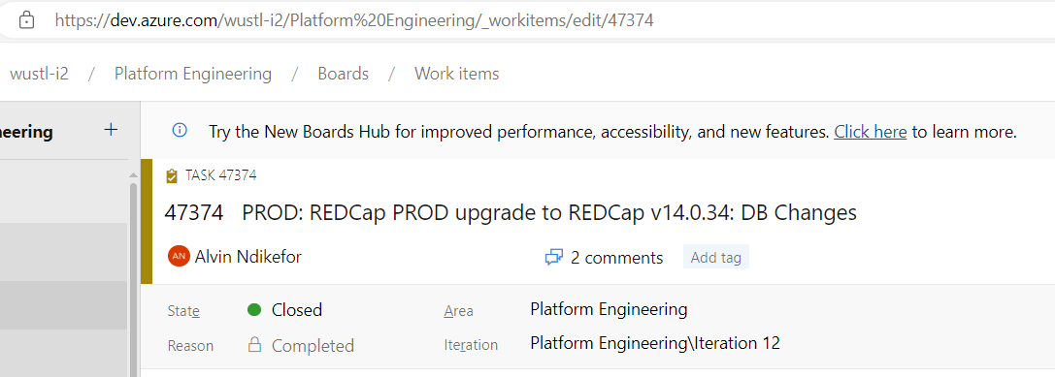
- Connect to Dbeaver database utility.  - In Dbeaver, connect to the appropriate database server & application database.  - After running the scripts, copy the script logs and paste it on the ticket. | 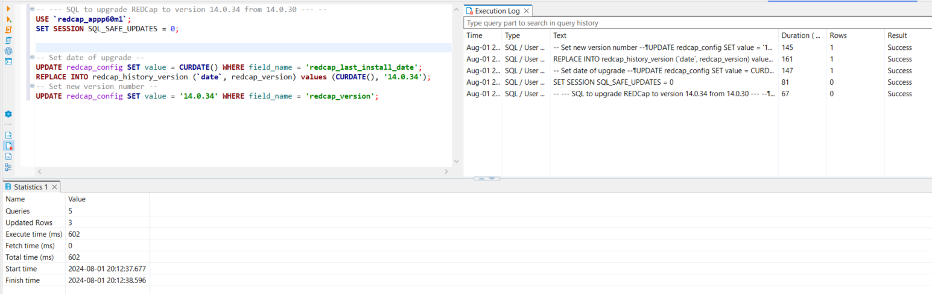
- Next, perform certain validation on the application to make sure the script ran successfully. | 